**CODES & RESULT**:

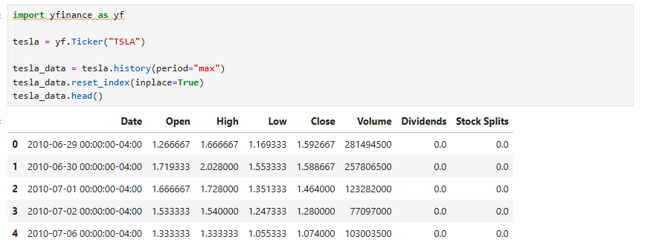



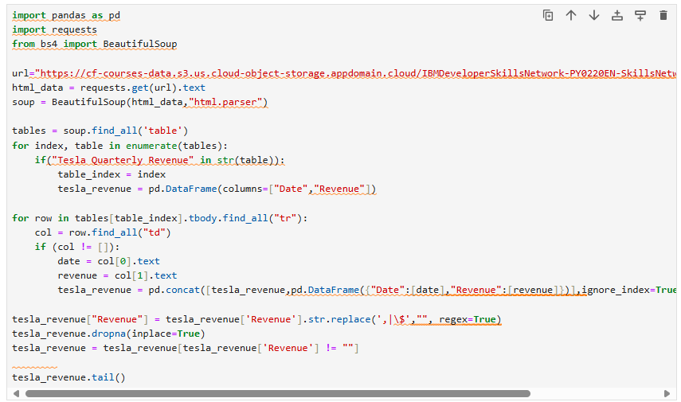

**CODES & RESULT**:

**CODES & RESULT**:

**CODES & RESULT**:



**CODES & RESULT**:

**CODES & RESULT**:

